**GOVERNMENT DENTAL COLLEGE & HOSPITAL, KADAPA.**

**DEPARTMENT OF PERIODONTICS**



**SEMINAR PRESENTATION ON “PERIODONTAL MICROBIOLOGY”**

GUIDED BY: PRESENTED BY:

DR.P.SURESH, DR.K.LATHA,

PROF & HOD, PG STUDENT.

DEPT. OF PERIODONTICS.

**CONTENTS**

* Introduction
* Diversity of Intraoral Surfaces For Bacterial Adhesion
* Structure & Composition of Plaque
* Accumulation of Dental Plaque Biofilm
* Factors Affecting Supra-gingival Dental Plaque Formation
* Characteristics of Biofilm bacteria
* Bacterial Transmission & Translocation
* Non-Bacterial Inhabitants of Oral Cavity
* Microbial Specificities of Periodontal Diseases
* Criteria for Identification of Periodontal Pathogens
* Role of Oral Microbiome in Health
* Events During trasition from health to periodontal disease
* Virulence factors of periodontopathogens
* References

**INTRODUCTION**

* Bacterial colonization of the oral cavity starts at the time of birth. Within few hours after birth, sterile oral cavity becomes colonizied by facultative and aerobic bacteria.
* At around 2 years, the entire human microbial flora is formed by a complex collection of microorganisms.
* After tooth eruption, a more complex oral flora is established, more than 500 different species are capable of colonizing the adult mouth.
* The oral cavity communicates with the pharynx and is considered as open growth system.

Diversity Of Intraoral Surfaces for Bacterial Adhesion

* On the basis of physical and morphological criteria, the oral cavity is divided into 6 major ecosystems. They are:

1. The intraoral and supragingival hard surfaces.
2. Subgingival regions adjacent to hard surface, including periodontal/peri-implant pocket.
3. The buccal, palatal epithelium and the epithelium of the floor of the mouth.
4. The dorsum of the tongue.
5. The tonsils.
6. The saliva.

* Bacterial adhesion to epithelial cells shows large inter-subject variability.
* Several studies clearly illustrate a positive correlation between the adhesion rate of pathogenic bacteria to different epithelia and the susceptibility of the patient to certain infections.
* The teeth and implants provide a hard, non-shedding surface that allows the bacterial deposition.
* Teeth are the primary habitat for periodontal pathogens.
* The teeth are considered as the “port of entry” for periodontal pathogens.

DENTAL PLAQUE – structure & composition

* Dental plaque is defined clinically as a structured, resilient, yellow-grayish substance that adheres tenaciously to the intraoral hard surfaces, including removable and fixed restorations.
* - Carranza
* Bacterial aggregations on the teeth or other solid oral structures.
* - Lindhe
* “Dental plaque is a specific but highly variable entity resulting from growth and colonization of micro-organisms on surfaces of teeth, restoration and soft- tissue, consisting of various species of microorganisms entangled in extracellular matrix.”
* - WHO.
* Plaque is primarily composed of bacteria in matrix of salivary glycoproteins and extracellular polysaccharides. This matrix makes it impossible to remove the plaque by rinsing or the sprays.
* Materia alba refers to soft accumulations of bacteria and tissue cells that lack organized structure and is easily displaced with a water spray.
* 1gm of dental plaque(wet weight) contains 1011  bacteria

Thin supragingival dental plaque of a 32-year-old man who had not brushed his teeth for 7 days. **A, Unstained plaque is not readily apparent. B, Extent of the** plaque becomes apparent when stained with a disclosing solution (i.e.,erythrosine dye)

* More than 700 distinct microbial species are found in dental plaque
* Non bacterial microorganism found in plaque include Mycoplasma species, yeasts, Protozoa and Viruses.

Dental Plaque Is Broadly Classified Into

Plaque Associated With Tooth Surface And Periodontal Tissues.

FORMATION OF DENTAL PLAQUE BIOFILM

* FORMATION OF THE PELLICLE
* INITIAL ADHESION / ATTACHMENT OF BACTERIA
* COLONIZATION/ PLAQUE MATURATION

**Formation of Pellicle**

* Acquired pellicle.
* Consists of Glycoprotein (mucins), Proline rich protein, Phosphoproteins (Statherin), Histidine rich proteins,enzymes.
* Forms within 1 min after introduction into the mouth of a volunteers.
* Two layers: thin basal layer, difficult to remove and a thick globular layer, easy to remove.

**Initial Adhesion and attachment of bacteria**

**Phase I : Transport to the surface**

* Initial contact of bacterium to tooth surface
* Random contacts through Brownian movement (40μm/hr)
* Through Active bacterial movement

**Phase II: Initial Adhesion**

* Reversible adhesion
* Interaction b/w bacteria and surface at certain distance (50nm) through long range and short range forces
* Including Vanderwall attractive and electrostatic repulsive forces
* **DLVO** theory states that **Gibbs total energy GTOT = GA + GE**
* At the physiologic ionic strength of saliva, the Van der Waal’s forces result in net attraction at a distances tens of nm from the surface.
* Electrostatic repulsion prevents bacteria from getting even closer to the surface.
* At a distance of 10 nm bacteria are reversibly bound. The stronger bonding at this point is the consequence of interaction between adhesins and receptors in pellicle.

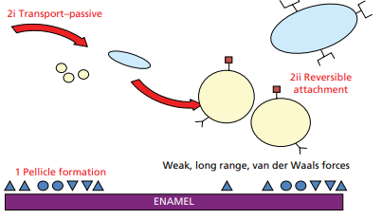

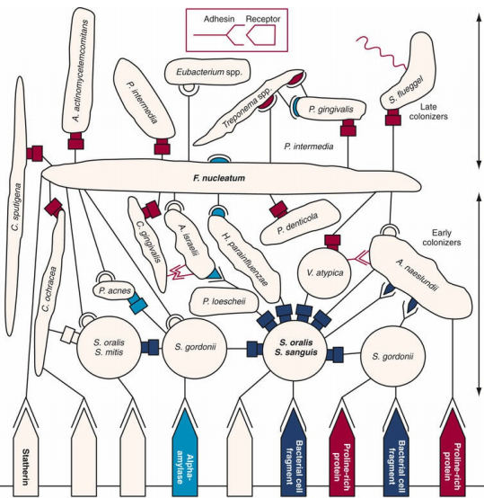

Schematic representation of interactions involved in bacterial adhesion to solid substrata

**Phase III: Strong Attachment**

* After intial adhesion firm adhesion is established by specific interactions (covalent,ionic or hydrogen bonds).
* Rough surfaces are more conducive for attachment as bacteria are better protected against shear force leading to change from reversible to irreversible bonding.
* The bonding between bacteria and pellicle is mediated by by specific adhesins on the bacterial cell surface and receptors in the pellicle.

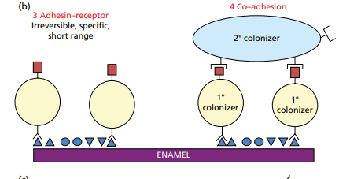

**Colonization and plaque maturation**

* The primary colonizing bacteria adhere to tooth surface and provide new receptors for other new bacterial attachment – Co-adhesion
* Direct Interaction between genetically distinct cell suspensions – Co-aggregation.
* Fusobacterium co-aggregate with all oral bacteria.

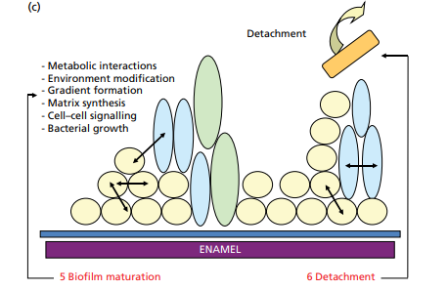

**CORN COB FORMATION**

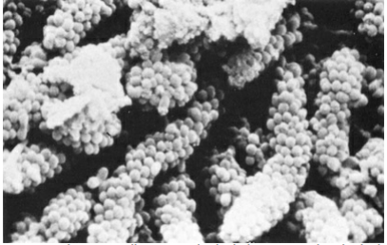

Factors affecting supragingival dental plaque formation

* An early undisturbed plaque follows an exponential growth curve.
* First 24 hrs- plaque is negligible (<3% of tooth surface).
* Next 3 days- rapid progression is seen.
* After 4 days- an average of 30% of the tooth is covered by plaque
* Bacterial growth of newly formed is much slower than old one.

Topography of Supragingival Plaque

* Early plaque formation follow typical topograhic pattern with initial growth along gingival margin and interdental space.
* Later further there is extension in coronal direction.
* This pattern changes when tooth contains surface irregularities such as grooves,cracks, perikymata, or pits.
* Surface irregularities can give rise to "individualized plaque growth pattern“.

Surface Microroughness

* Rough intraoral surface (crown,implant abutments, denture bases) accumulate and retain more plaque and calculus in terms of thickness, area.
* **[Ra=0.2µ]** is threshold for surface roughness above which bacterial adhesion is facilitated.

Individual variables influencing plaque formation

* Rate of plaque formation differs between subjects, a distinction is made between heavy(fast) and light(slow) plaque formers.
* Simonsson and co-workers compared between the above groups in a comparitive analysis and found minor differences and no single variable explained the difference.
* A multiple regression analysis showed that the clinical wettability of tooth surface, saliva induced aggregation of bacteria, relative salivary flow condition around the tooth explained the 90% of the variation.

Variation within the Dentition

Early plaque formation **occurs faster** in

* **lower jaw** compared to upper
* **Molar areas**
* **Buccal tooth surfaces** as compared to oral sites (esp in upper jaw)
* **Interdental region** compared to buccal or oral surfaces

Impact of Gingival inflammation & Saliva

* Early **in vivo plaque formation is more rapid** on tooth surfaces facing **inflamed gingival** margins than those adjacent to healthy gingival margins.
* Increase in crevicular fluid production enhances plaque formation.

Impact of Age

* Recent studies show that subject’s age does not influence de novo plaque formation.
* Fransson et al stated that no differences are detected in plaque formation between younger and older subjects.

Spontaneous tooth cleaning

* Many clinicians believe that plaque is removed spontaneously by eating, but the firm attachment between bacteria and surface, this is unlikeky.
* Even occlusal part of molars, plaque remains after chewing fibrous food.

De novo subgingival plaque formation

* Recent studies suggest that complex subgingival microbiota, including most periopathogens, is established within 1 week after abutment insertion.
* Smooth abutments[Ra<0.2µ] were found to harbour less bacteria than rough surfaced ones, with a slightly higher density of coccoids (i.e nonpathogenic) cell.

Characteristics of biofilm bacteria

* Metabolism of dental plaque bacteria
* Communication between biofilm bacteria
* Interaction between bacteria
* Biofilm and antimicrobial resistance

Metabolism of dental plaque bacteria

* Saliva, GCF, occasional but important dietary food.
* The **transition from Gm+ve to Gm-ve** microorganism observed in structural development of plaque is paralled by **physiologic transition** in the developing plaque.
* Early colonizers use oxygen and **lower redox potential** of the environment which then favors growth of anaerobic species.
* **Early colonizers** use **sugar** as energy source and saliva as carbon source
* **Bacteria** which predominate in **mature plaque or late colonizers** are **Asaccharolytic** and use amino acids and small peptides as energy source
* Lactate and formate are by products of metabolism of streptococci and actinomycetes may be used by other microorganism
* **Hemin** a breakdown product from host hemoglobin is important in metabolism of **P gingivalis**
* Increase in **steroid hormone** is associated with increase in proportions **of Prevotella intermedia in subgingival plaque**

**Metabolic interaction among different bacteria species found in plaque and also between host and plaque bacteria**

QUORUM SENSING

* Bacteria in biofilm communicate with each other.
* This involves the **regulation of expression of specific genes** through **accumulation of signalling compounds** that mediate intercellular communication.
* When these signalling compounds reach a threshold level(quorum cell density) gene expression is activated.
* **Quorum sensing** seems to play a role in **expressing genes for antibiotic resistance** and **encouraging growth** of **beneficial species** to the biofilm and **discouraging** the growth of competitors.

Interactions between plaque bacteria

* Several clinical studies showed a relative proportions of cariogenic species after periodontal therapy.
* This shift is observed after initial and the surgical periodontal therapy; explained by subgingival outgrowth by S.mutans occupying the spot that became available after periodontal therapy.
* Some evidence suggest that the non-pathogenic organisms in subgingival plaque can modify the behaviour of periodontal pathogens.
* Eg: long and short fimbriae of P.gingivalis are required for adhesion and biofilm formation. The long fimbriae expression is downregulated by S.cristatus and short fimbriae are downregulated by S.gordonii, S.mitis.

ANTIBIOTIC RESISTANCE

* Microorganisms in biofilm are 1000 to 1500 times more resistant to antibiotics than in their planktonic stage.
* The mechanism of this increased resistance differs from species to species, from antibiotic to antibiotic, and for biofilm growing in different habitats.
* Resistance of bacteria to antibiotics is affected by their:
  + Nutritional status
  + Growth rate
  + Temperature
  + PH
  + Prior exposure to subeffective concentrations of antibiotics.
* Also slower growth of bacterial species in biofilm is another important mechanism of antibiotic resistance.
* Biofilm matrix although not significant barrier in itself to diffusion of antibiotics but have certain properties to resist diffusion.
* Biofilm act as ion-exchange resin removing antibiotics from solution.
* Also extracellular enzymes such as **β lactamases, formaldehyde lyase and formaldehyde dehydrogenase** may become trapped and concentrated in the extracellular matrix thus inactivating some antibiotics(especially **positive charged hydrophilic antibiotics).**
* “**Super-resistant” bacteria** have been identified within a biofilm and these cells have **multidrug - resistant pump** that can **extrude antimicrobials from the cell.**

Exchange of genetic material:

1. **Conjugation (sex pilus)**
2. **Transformation (**movement of small pieces of DNA from enviroment into bacterial chromosome)
3. **Plasmid tranfer**
4. **Transposon transfer** (DNA sequence which can change sequence within the genome)

Bacterial Transmission and Translocation

* Transmission of bacteria is important in infectious disease. In theory, such transmission may jeopardize the out of periodontal therapy.
* Molecular finger printing techniques clearly illustrate that periodontal pathogens are transmissible within the members of the family. Asikainen and co-worker stuided the genotype of A.a.
* Intra-oral transmission of bacteria was first examined in cariology by Loesche and co-workers.
* Christersson and co-workers demonstrated a translocation of A.a via periodontal probe in localised juvenile periodontitis patients. The non-infected pockets were colonized with A.a temporarly.
* And the colonization of already established microbial niche by a new species is difficult, since it is hampered by variety of microbial interactions.

NON-BACTERIAL INHABITANTS

* More diverse microbiotia is seen in oral cavity. Viruses, fungi, archaea and protozoa are seen as commensal in oral cavity and at times they may cause severe oral diseases.

**Viruses**

* Four major families of viruses are seen:

1. Herpes virus group.
2. Human Papilloma viruses.
3. Picornaviruses.
4. Retroviruses.

**Yeasts**

* Majority of isolates are Candida and the most prevalent species is C.albicans.
* Yeasts like Rhodotorula glutinis and Saccharomyces cerevisiae are found in the oral cavity rarely.
* Cryptococcus neoformans is ocassionally isolated from the mouth.

Microbiological specificity of periodontal diseases

* Non-Specific Plaque Hypothesis
* Specific Plaque Hypothesis
* Ecological Plaque Hypothesis
* Keystone Pathogen hypothesis

NON-SPECIFIC PLAQUE HYPOTHESIS

* Proposed by WALTER LOESCHE, 1976.
* Periodontal disease results from elaboration of noxious products from entire plaque flora.
* Large amount of plaque produces large amount of noxious product that would overwhelm host’s defense.
* Control of periodontal disease depend on control of amount of plaque deposit.
* The current standard treatment of periodontitis still focuses on the removal of plaque and its product founded on non-specific plaque hypothesis.

SPECIFIC PLAQUE HYPOTHESIS

* It was given by Newman and Socransky in 1977.
* States that only certain plaque is pathogenic and its pathogenecity depends on presence of or increase in specific microorganism.
* **Plaque harbouring specific bacterial** **pathogen results in periodontal disease because these organism produce substance that mediate the destruction of host tissue.**

Eg: A. actinomycetemcomitans as pathogen in localized aggressive periodontitis.

**Ecological plaque Hypothesis**

* Given by **Marsh & Co- Workers in 1990.**
* **Total amount of dental Plaque and the specific microbial composition** of plaque contribute to transition from **health to disease.**
* Disease is caused by the overgrowth of specific elements of dental plaque when the local microenvironment changes, but it is not necessarily the same species in each case.

Keystone Pathogen Hypothesis

* George Hajishengallis and colleagues stated this concept in the year 2012.
* It indicates that certain low-abundance microbial pathogens can cause inflammatory disease by increasing the quantity of the normal microbiota and by changing its composition.
* P.gingivalis is shown to be able to manipulate the native immune system of the host. By doing so it was hypothesized that it does not only facilitate its own survival and manipulation, but also entire microbial community.

**Criteria for identification of Periodontal pathogen**

**Kochs Postulates**

* Must be routinely isolated from diseased individual
* Must be grown in pure culture in laboratory
* Must produce similar disease when inoculated in susceptible laboratory animal
* Must be recovered from lesions in diseased laboratory animal

**Koch’s criteria are difficult to apply in periodontal disease because of following reasons:**

1. Inability **to culture** all microorganism that have been associated with disease (eg: spirochetes).
2. The difficulties inherent in **defining and culturing sites of active disease.**
3. **Lack of good animal model** for study of Periodontitis.

Periodontal Health

* Gm+ve facultative species of genera Streptococcus and Actinomycetes(S.sangius, S.mitis, A.viscosus, A.naeslundi)
* Small proportions of Gm-ve speciesa are also found (P.intermedia, F.nucleatum, Capnocytophaga, C.ochareus)

Role of the Oral Microbiome In Health

* Evidence suggest that human microbiome performs diverse functions that are benicifial for human, these effects are primarily seen in the gut.
* It is hypothesised that the primary function of resident flora is to act as a physical and biochemical barrier to prevent colonization or infection by exogenous organisms.
* The second hypothesised function is to promote maturation of the both innate and adaptive host immune system, mainly to achieve balance between pro and anti-inflammatory processes.
* In addition, it is hypothesised to contribute to unique functions of human health and homeostasis.

Events During the Transition from Health to Periodontal Disease

* In a longitudinal study of long-term healthy subgingival sites and the sites that progressed to periodontal disease in human subjects, P.gingivalis displayed upregulation of large number of virulence genes in healthy sites that later progresses to disease, while T.denticola and T.forsythia do not upregulate many, but one or few virulence genes.
* It suggests that P.gingivalis serves as microbial driver in the transition from periodontal health to disease when present.
* Molecular analysis in experimental gingivitis reveal an unique cohort of microbes associated with gingivitis but not in health or chronic periodontitis, and composed of F.nucleatum sub-species polymorphum, Lachnospiraceae sps, Lautropia sps, Prevotella oulorum.

VIRULENCE FACTORS OF PERIODONTOPATHOGENS

* It is clear that some organisms like P.gingivalis, A.actinomycetemcomitans, spirochetes and P.intermedia are strongly associated with periodontal disease.
* Targeting one or more pathogens will not necessarily cure disease, it may make sense to focus on the specific molecules that contribute to the disease.
* Virulence factors of bacteria can be divided into:

1. Factors that promote colonization.
2. Toxins and enzymes that degrade host tissues.
3. Mechanisms that protect pathogenic bacteria from the host.

ADHESIVE SURFACE PROTEINS AND FIBRILS

* To colonize the periodontal pocket, bacteria must adhere to cells or tissues in the region of the teeth, existing microbial biofilm, or the pocket epithelium.
* Fimbriae or pili or polymeric fibrils composed of repeating subunits that can extend several microns from the cell membrane.

FACTORS THAT PROMOTE TISSUE DESTRUCTION

* Fimbriae of P.gingivalis and A.actinomycetemcomitans are highly antigenic.
* Bacterial proteolytic activity in dental plaque, particularly trypsin-like protease activity, is closely correlated with clinical marker of periodontal disease.
* The bulk of host tissue degrading activity is restricted to a small number of enzymes. In case of P.gingivalis three enzymes known as “gingipains” are responsible for at least 85% of the total host protein degradation activity.
* The gingipains belong to cysteine protease family, that utilize an active site cystiene residue for catalysis. They are classed as Arg-gingipains (Rgp A, Rgp B) or Lys-gingipain (Kgp)

STRATEGIES FOR EVADING HOST IMMUNITY

* Production of extracellular capsule.
* Proteolytic degradation of host innate and acquired immunity.
* Modulation of host responses by binding to serum components.
* Invasion of gingival epithelial cells.
* Strains of P.gingivalis produce polysaccharide capsules that surround the outer membrane. Six different antigenic capsule types have been described based on differences in the polysaccharide K antigen.
* A.a produce a 100 kDa protein on the outer membrane (ApiA) that mediates adhesion and invasion of host cells.

**REFERENCES**

* Carranza’s Clinical Periodontology -10th edition.
* Clinical Periodontology and Implantology Dentistry – Jan Lindhe, Niklaus P.Lang – 6th edition.
* Scokransky SS, Haffajee AD, Cugini MA, J Clin Periodotol 25:134, 1998.
* Valm AM, The Structure of Dental Plaque Microbial communities in the transition from health to dental caries and periodontal disease, J Mol Biol, 2019 26:431(16): 2957-2969.